Azure Backup
Azure Backup, an underlying technology of Operations Management Suite, is a scalable solution that protects your application data with zero capital investment and minimal operating costs. Azure Backup can retain your data for up to 99 years to meet regulatory requirements.

What can I back up?
- On-premises - Back up files, folders, system state using the Microsoft Azure Recovery Services (MARS) agent. Or use the DPM or Azure Backup Server (MABS) agent to protect on-premises VMs (Hyper-V and VMware) and other on-premises workloads
- Azure VMs - Back up entire Windows/Linux VMs (using backup extensions) or back up files, folders, and system state using the MARS agent.
- Azure Managed Disks - Back up Azure Managed Disks
- Azure Files shares - Back up Azure File shares to a storage account
- SQL Server in Azure VMs - Back up SQL Server databases running on Azure VMs
- SAP HANA databases in Azure VMs - Backup SAP HANA databases running on Azure VMs
- Azure Database for PostgreSQL servers (preview) - Back up Azure PostgreSQL databases and retain the backups for up to 10 years
- Azure Blobs - Overview of operational backup for Azure Blobs

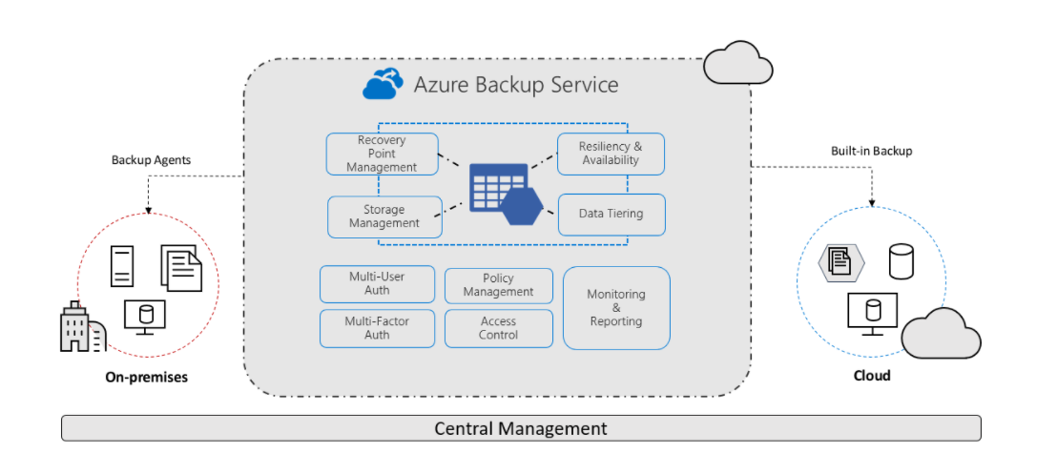

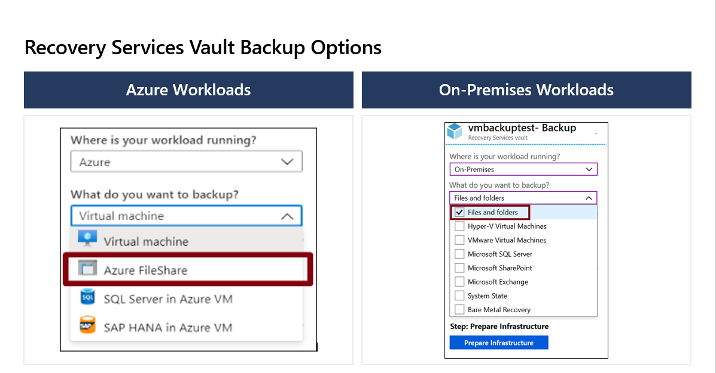

A Recovery Services vault is a storage entity in Azure that houses data. The data is typically copies of data, or configuration information for virtual machines (VMs), workloads, servers, or workstations. You can use Recovery Services vaults to hold backup data for various Azure services such as IaaS VMs (Linux or Windows) and Azure SQL databases. Recovery Services vaults support System Center DPM, Windows Server, Azure Backup Server, and more. Recovery Services vaults make it easy to organize your backup data, while minimizing management overhead. Recovery Services vaults are based on the Azure Resource Manager model of Azure, which provides features such as:
- Enhanced capabilities to help secure backup data: With Recovery Services vaults, Azure Backup provides security capabilities to protect cloud backups. The security features ensure you can secure your backups, and safely recover data, even if production and backup servers are compromised. Learn more
- Central monitoring for your hybrid IT environment: With Recovery Services vaults, you can monitor not only your Azure IaaS VMs but also your on-premises assets from a central portal. Learn more
- Azure role-based access control (Azure RBAC): Azure RBAC provides fine-grained access management control in Azure. Azure provides various built-in roles, and Azure Backup has three built-in roles to manage recovery points. Recovery Services vaults are compatible with Azure RBAC, which restricts backup and restore access to the defined set of user roles. Learn more
- Soft Delete: With soft delete, even if a malicious actor deletes a backup (or backup data is accidentally deleted), the backup data is retained for 14 additional days, allowing the recovery of that backup item with no data loss. The additional 14 days of retention for backup data in the "soft delete" state don't incur any cost to you. Learn more.
- Cross Region Restore: Cross Region Restore (CRR) allows you to restore Azure VMs in a secondary region, which is an Azure paired region. By enabling this feature at the vault level, you can restore the replicated data in the secondary region any time, when you choose. This enables you to restore the secondary region data for audit-compliance, and during outage scenarios, without waiting for Azure to declare a disaster (unlike the GRS settings of the vault). Learn more.
For creation of Recovery services Vault follow the below article:
Create and configure Recovery Services vaults - Azure Backup | Microsoft Docs

On-prem Backup

